|  |  |
| --- | --- |
|  | standard logo - light green ink-BIG  EN_ArchPro  Living Danube Limes Croatia -  fieldwork report 2021  Filename: Living\_Danube\_Limes\_Croatia\_fieldwork\_report\_2021.docx |
|  |  |
|  | **Main Authors:** David Ruß, Roland Filzwieser  **LBI Team**: David Ruß, Gerhard Stüttler, Roland Filzwieser  13. 01. 2021 |
|  | Archaeological geophysical prospection in the framework of the EU Interreg DTP359 Living Danube Limes. |

# Abstract

The fieldwork in Kopačevo was carried out between November 11th and 13th 2021. The area selected as area of interest primarily could not be investigated because the landowner refused to grant permission to enter the area of a Roman fortlet in the village. For this reason, areas around the village and north of the small fortress were examined for two days. A 16 channel GPR system Mala MIRA with a frequency of 400 MHz was used.

# Methodology

Over the past years geophysical prospection methods have developed to become an indispensable set of tools in archaeology and enjoy increasing popularity. From the numerous available methods, in particular magnetic prospection, earth resistance and GPR (ground penetrating radar) measurements have proven to be of particular use for archaeological applications. These methods permit the detection and mapping of buried man-made structures by measurement of the physical properties of the subsurface. In the case of archaeological prospection applications, dedicated measurement configurations are used for the spatial, gridded sampling with dense sample spacing for the investigation of several hectares of area in a short period of time. Data analysis and visualisation are conducted using specially developed processing algorithms and software.

The potential of the methods used is primarily determined by the contrast of the physical properties of the soil in comparison to the present archaeological structures. From experience, under suitable conditions the magnetic prospection method can detect a diverse range of structures of archaeological interest (for example pits, postholes, trenches, hearths, furnaces, walls, track ways, and palisade trenches). Arrays of optically pumped Caesium magnetometers as well as of Fluxgate type gradiometer instruments represent the most eﬃcient, magnetic prospection tools today.

Both in the case of magnetic and GPR measurements, a preliminary data analysis is possible on site for quality control and further planning of the survey. For detailed data analysis, powerful computer and special processing software are used. The visualised data of the individual measurements are combined in the form of georeferenced greyscale-images that are interpreted archaeologically including all available information (e.g. terrain models, already known and registered archaeological remains, soil maps, written sources etc.) in the framework of a Geographic Information System (GIS) by experienced experts.

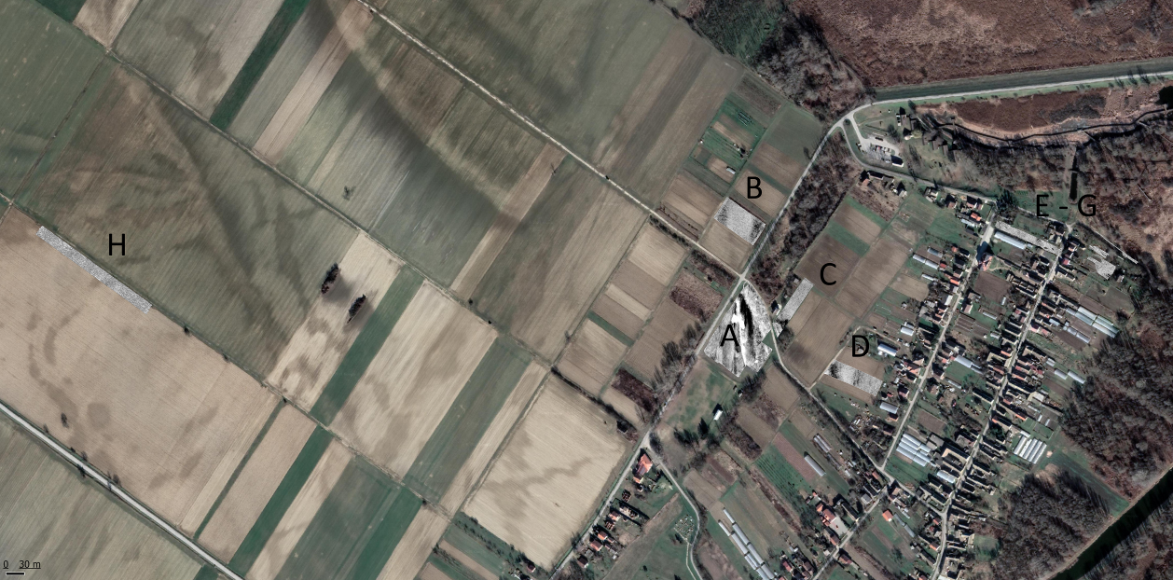

Figure 1: Areas investigated with GPR in Kopačevo, Areas A to D on the first day, E to H on the second.

## Basic principles of ground penetrating radar measurements

Ground penetrating radar (GPR) is currently the potentially most efficient geophysical archaeological prospection method. The GPR method is based on the reflection of electromagnetic waves in the subsurface. An electromagnetic pulse with maximum amplitude of a certain frequency (in general between 250 MHz and 500 MHz) is emitted into the subsurface using a transmitter antenna. This pulse is travelling through the ground with a velocity dependent on the traversed material, and it is reflected from individual objects or interfaces with differing physical properties (i.e., dielectric permittivity, electric conductivity).

The part of the emitted signal that is returning to the surface is recorded with a receiver antenna and digitized. Changes in signal amplitude and frequency carry information about the composition of the subsurface (soil humidity, porosity, clay content) and contained structures. The travel time of the signal is proportional to the distance of reflecting objects or interface.

It is mainly the dielectric permittivity of the medium, its electric conductivity, the radiation characteristics of the antennae used, and the frequency content of the emitted GPR pulse that govern its propagation in the subsurface (maximum signal penetration depth, vertical and horizontal resolution).

The contrast of the dielectric permittivity of two media determines the amount of energy reflected from objects or at layer interfaces. In the upper soil layers strong reflection coefficients are caused by changes in the substrate, by strong inhomogeneities due to varying soils humidity, and by contained anthropogenic objects or structures (e.g., utilities, foundation walls).

The absorption of the electromagnetic energy transmitted into the ground depends on the transversed medium (material dependent absorption loss). The reduction in signal amplitude of the transmitted energy pulse depends mainly on the electrical conductivity of the medium and the travelled distance, with the conductivity being the determining factor for the actual penetration depth of the electromagnetic pulse. By comparing amplitudes, it is possible to differentiate areas according to their absorption properties.

GPR antennae emitting a low frequency signal (e.g., 100 - 200 MHz) permit a greater depth of investigation at reduced resolution, due to the longer wavelength of the signal. High-frequency signals (e.g., 800 - 1000 MHz) offer greatest resolution, but only limited signal penetration (< 1 m). GPR antennae commonly used for archaeological prospection operate with signals centred around 400 or 500 MHz, offering investigation depths of 1.5 - 3 m and sufficient resolution.

### Data processing and analysis

In general, GPR data contain a large amount of information. The visualisation of GPR data is commonly realized in form of greyscale images showing the amplitudes of the recorded signals as a function of space and time.

Within the individual GPR sections, representing vertical cuts through the subsurface, typical reflection and diffraction patterns of the signals can be observed that are generally very difficult to interpret. Often comments and explanatory line drawings are inserted into such GPR section presentations. However, the use and visualisation in form of vertical GPR sections is today rather uncommon in geophysical archaeological prospection and outdated, with exception of special applications.

The individual GPR sections collected manually or with motorized survey systems are merged after the fieldwork in the computer using specially developed software solutions. Through interpolation a virtual three-dimensional data block is generated. If the velocity of the GPR signal in the subsurface is known or estimated (a value commonly used is a constant velocity for the entire subsurface of 10 cm/ns; however, variations between 5 and 15 cm/ns can be encountered), it is possible to convert the vertical axis of the data volume from time to depth.

This digital block of data can be cut into horizontal slices, so called GPR time-slices or GPR depth-slices. Slices of different thickness can be computed, e.g., 5 cm, 10 cm, 20 cm, 30 cm, 40 cm, and 50 cm thick slices, averaging variable amounts of information contained in the data volume.

Using these slices, it is possible to map and image archaeological structures that occur at approximately the same depth, considerably facilitating their archaeological interpretation since the spatial context becomes clear to the observer. By scrolling through a stack of thin GPR depth-slices in form of a quick succession of images or an animation, it becomes possible to understand the spatial extent of structures contained in the data. While the relative depth of structures imaged using the GPR method is correctly imaged, it should be kept in mind that the absolute depth of the structures can vary due to the lack of knowledge of the exact GPR signal velocity distribution in the imaged volume. Selective velocity analyses can be conducted when reflection hyperbolae are observed in the GPR profile data, or when a dedicated common-mid-point survey and moveout analysis is performed.

Common data processing steps applied to the data prior to 3D volume generation include trace interpolation, band-pass frequency filtering, spike removal, dewow filter, average-trace-removal, amplitude gain correction, amplitude balancing and Hilbert transformation. In special cases it can be useful to utilize volume rendering to visualise certain anomalies or structures contained in the data. All generated data images are georeferenced for a subsequent archaeological interpretation in GIS.

## Fieldwork

The fieldwork in Kopačevo was carried out between the 16th and 18th of November 2021. On the first day, GPR surveys were conducted east of the village around the Footballfield (Fig. 1). No permission could be obtained from the landowner for the originally planned investigation area of a Roman fortlet in the northeast of Kopacevo.

In the area of ​​the old football field and the basketball court, the humus overlying the gravel was lifted, so the data measured in the largest contiguous area is the most varied, the different gravel belts are easy to distinguish. A total of around 1.7 hectares were measured on the first day. The following day, due to technical problems with a GPS antenna, a measurement was not possible, so a visit to the Archaeological Museum Osijek and a tour of the archaeological sites in Batina (Iron Age settlements and burial grounds, Roman military camp, battle of World War II) were on the program. On the last day, areas north of the small fort in an area of ​​about 0.3 hectares and about 0.4 hectares about one kilometer east of the village were examined.

This means that GPR data are available for around 2.4 hectares.

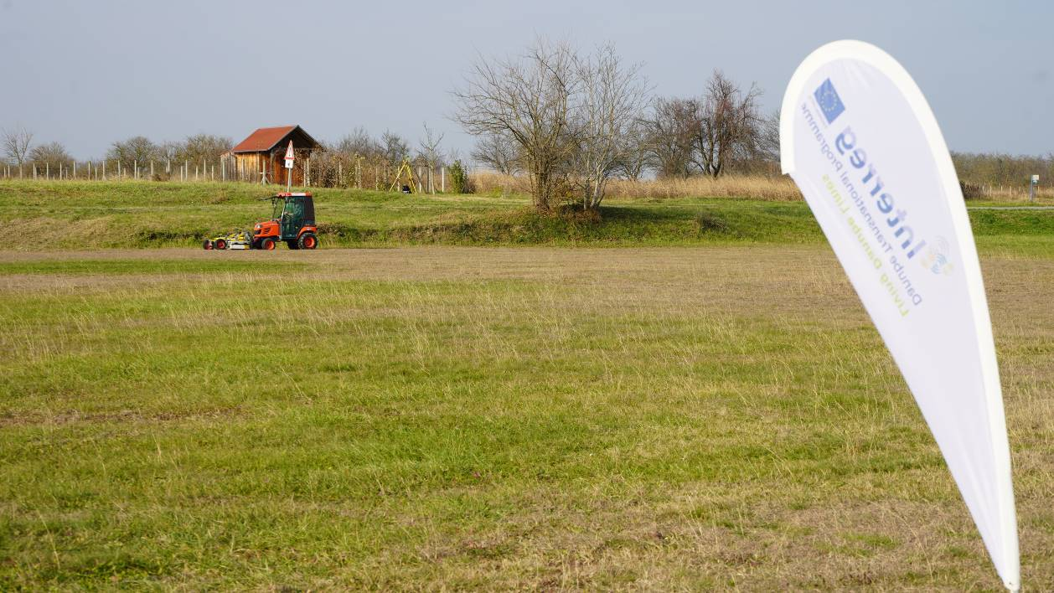

Fig. 1: Motorized MALÅ Imaging Radar Array (MIRA) at Kopačevo.

### GPR survey system

The MALÅ Imaging Radar Array (MIRA) used is a high resolution GPR array consisting of 8 receiver and 9 transmitter antennae with a centre frequency of 400 MHz. Transmitters and receivers are mounted in two rows with an offset of half an antenna width in a ruggedized box. The box is mounted on the front hydraulics of Kubota mini tractor, which allows a floating position and subsequently ideal ground contact of the antenna box.

Each of the receiver antennae records the signal of the two neighbouring transmitter antennae. The cross line spacing between the resulting 16 channels is therefore reduced to 8 cm. In total a 132 cm wide swath of 16 single GPR sections is recorded for each driven line.

Surveys were conducted with each channel constantly recording 50 single measurements per second leading to an in-line trace spacing of 2-4 cm depending on the actual driving speed (a maximum of 10 km/h can be achieved with the Kubota). The resulting minimum spatial resolution for this survey therefore amounts to 8 x 4 cm. Each recorded GPR trace is averaged from 4 measured traces (4 stacks). The record time of the systems was set between 60 and 80 ns allowing a maximum penetration depth of 3 – 3.5 m (at an assumed GPR signal velocity of 0.1 m/ns) A ruggedized industrial PC equipped with the software products MIRAsoft (MALÅ) and LoggerVIS (LBI ArchPro) is mounted in the Kubota minitractor and was used for data acquisition, measurement control and navigation. The centimetre accuracy for positioning was provided by a Javad GNSS system in base and rover configuration.

## First results

Area A and C: The main features are some rectangular and one circular pit for an unknown purpose. In addition, there are some linear structures in area A, which probably represent modern infrastructural installations. At the southern end of area C there is a square of walls measuring about 5 meters by 5 meters. To the southwest of it, an area of increased reflectivity emerges, perhaps rubble or gravel.

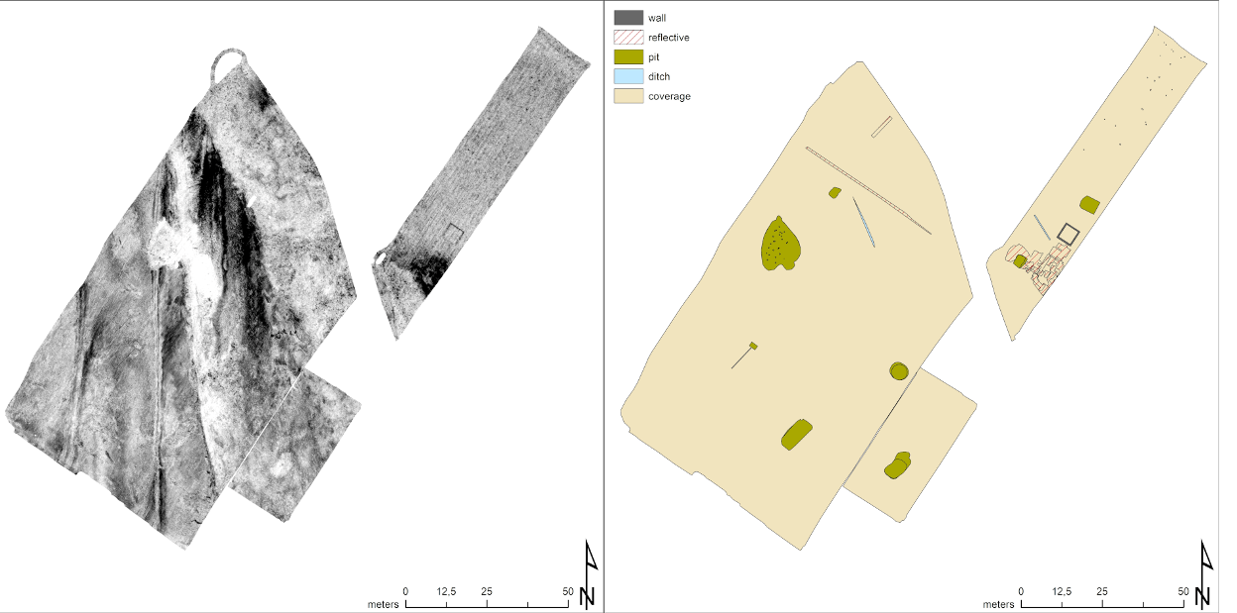

Figure 2. Area A and C. Left: Depthslice 40 cm - 60 cm. Right: Interpretation of all Depthslices.

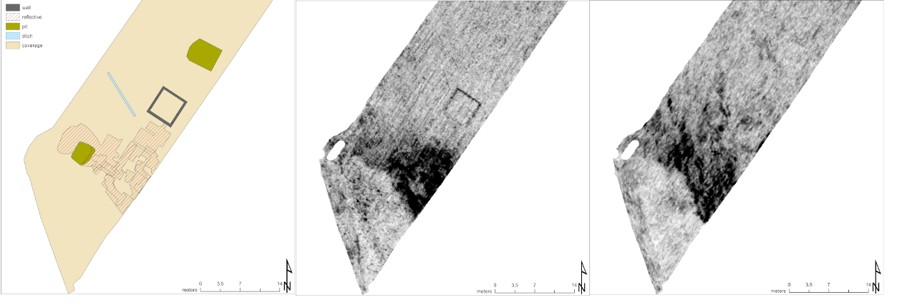

Figure 3. Area C. Left: Interpretation of all Depthslices. Middle: Deptslice 40 cm - 60 cm. Right: Depthslice 140 cm - 160 cm.

Area B: In area B there are no clear archaeological features visible.

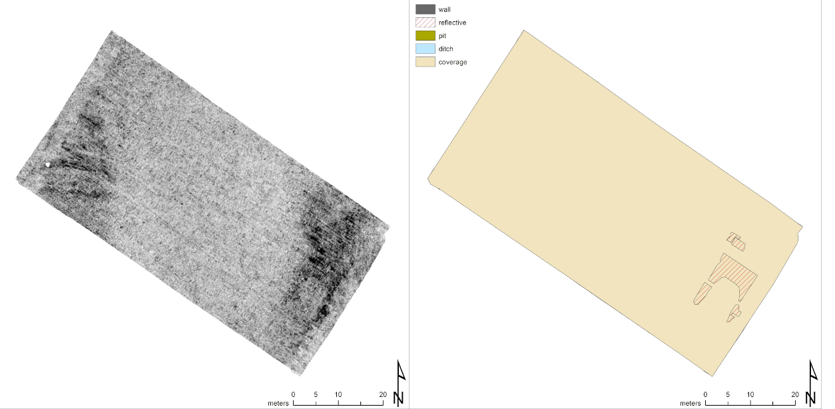

Figure 4. Area B. Left: Depthslice 60 cm - 80 cm. Right: Interpretation of all depthslices.

Area D: In Area D only a modern infrastructural installation (drain?) is visible.

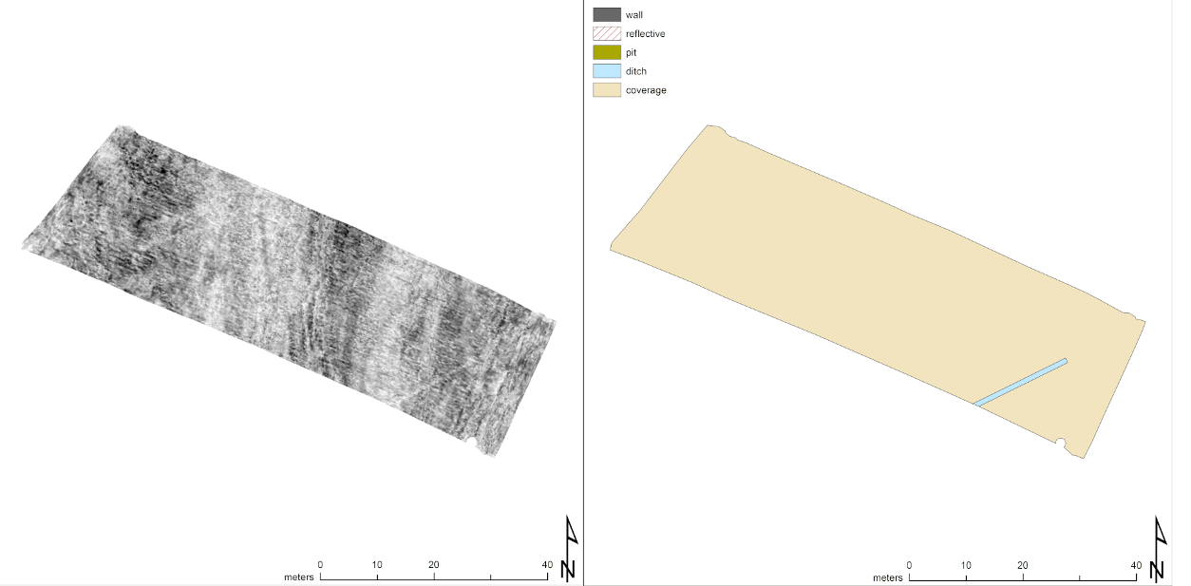

Figure 5: Area D. Left: Depthslice 140 cm - 160 cm. Right: Interpretation of all depthslices.

Areas E-G: Apart from a pit, only modern infrastructural fixtures have so far been clearly visible in these areas.

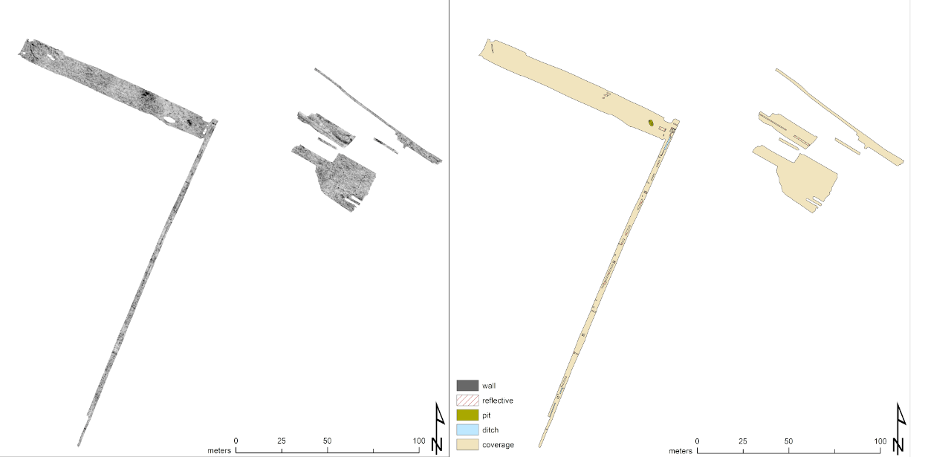

Figure 6. Area E-G. Left: Depthslice 40 cm - 60 cm. Right: Interpretation of all depthslices.

Area H: Several large pits were identified here, their purpose is not clear.

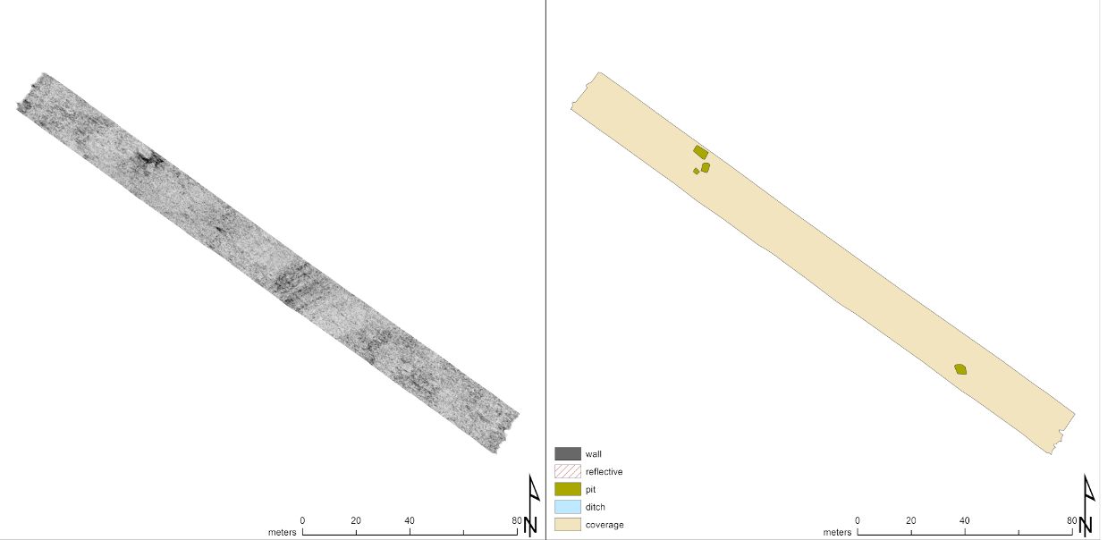

Figure 7: Area B. Left: Depthslice 40 cm - 60 cm. Right: Interpretation of all depthslices.

# Bibliography

Fassbinder, J.W.E. & H. Stanjek. 1993. Occurrence of bacterial magnetite in soils from archaeological sites *Archaeologia Polona* 31: 117–28.

Le Borgne, E. 1955. Susceptibilitée magnétique anomale du sol superficiel *Annales de Geophysique* 11: 399–419.